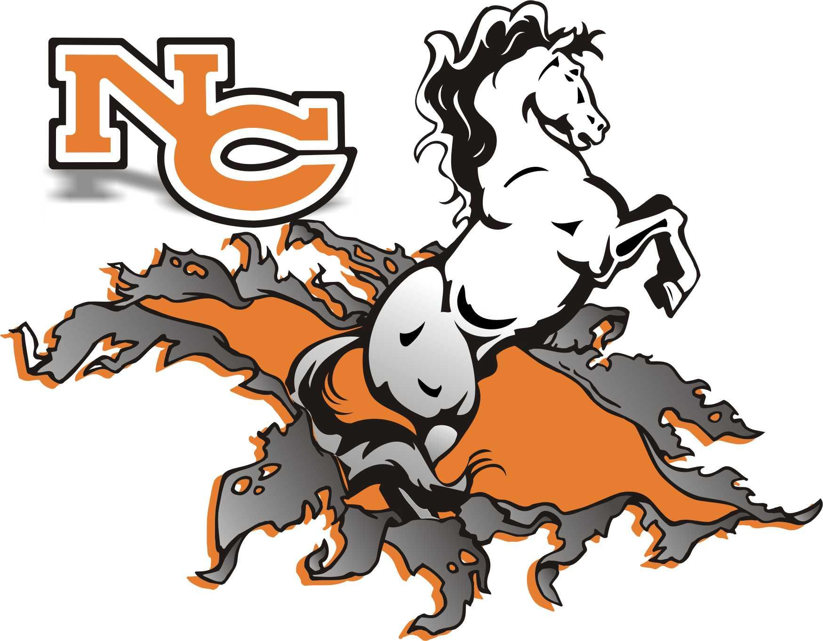

***Mustang Handbook***

***2019-2020***

***“Every Day is a***

***GREAT Day***

***To be a***

***MUSTANG!!!”***

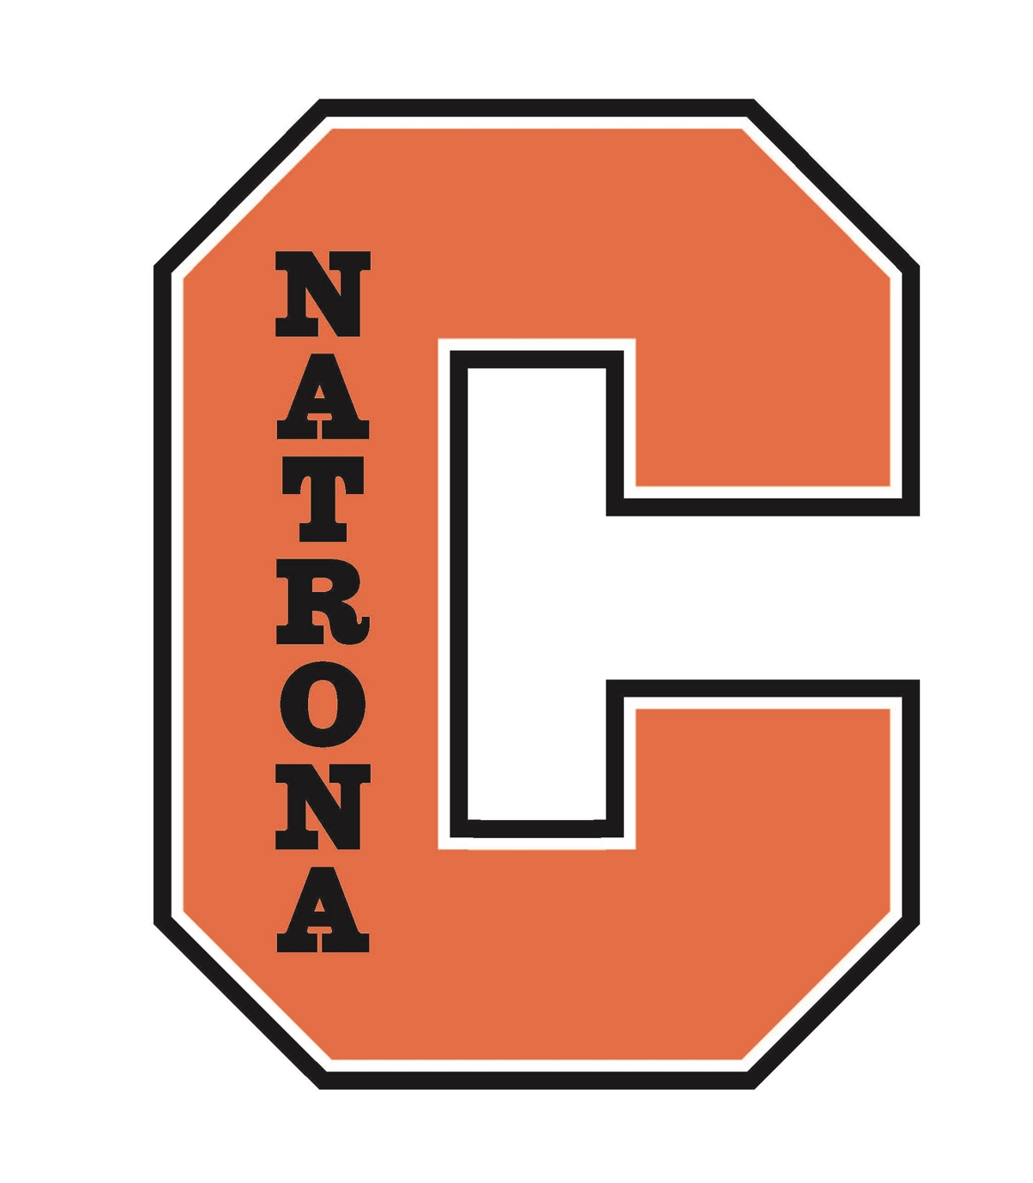

**NCHS SCHOOL SONG**

All hail,

To Casper High School,

N. C. H. S.

Hail to our Casper

Hail, hail, hail, hail,

Hail to Casper

Dear old Casper

Hail, to Casper High School

Always on top,

We’ll yell for Casper High

And never stop.

**Table of Contents**

School Song 2

Table of Contents 3

Administrative Welcome 4

Administrators, Counselors, & Campus Supervisors 5

Strategic Goals 6

**School Information**

Activity Eligibility 7

**Student Expectations**

Assemblies 8

Assessments & Student Incentives 8

Attendance Policy 10

Bicycles & Skateboards 11

Bullying Policy 11

Campus Community 12

Campus Restrictions by Grade Level 12

Cell Phones 12

Course Fees 12

Code of Conduct 12

College Coach 12

Conflict & Mediation 13

Dress & Appearance 13

Honor Code 14

Honor Rolls & Quality Points 14

Identification Card 14

International Baccalaureate 14

Library 15

Lockers 15

Parking 15

Progress Reports 16

Public Displays of Affection 16

Student Class Rank 17

Student Schedules 17

Safe School Suspension Lab 18

Sexual Harassment 18

School Safety/Security 18

School Dances 18

Student Drop-off/Pick Up 19

Student Insurance 19

Technology 19

Vaping 20

Visitors 20

Visiting Other School Campuses 20

**Appendix**

Instructional Technology Acceptable Use Agreement 21

Student Technology Pledge 24

Parent/Guardian & Student Agreement 25

Handbook Acknowledgement Form 26

Bell Schedule 27

NCHS Orange/Black Calendar 28

Dear NCHS Students,

NCHS has a rich history and tradition that you are now a part of. We hope you come to school each day excited to learn. Your journey toward excellence continues each day as you enter the doors of NCHS. Over the course of your high school career, you will spend 700 days here preparing for your future. As Muhammad Ali once said, *“Don’t count the days, make the days count!”*

Faculty and staff are here to assist you in attaining your goals. One of our mottos at NCHS is “BBOY?”. This question is asking, is NCHS “Better Because Of You?” Staff and students continually strive to make NCHS better because of their contributions. Come to school each day in partnership with staff to ensure NCHS is BBOY. Confucius said, *“The will to win, the desire to succeed, the urge to reach your full potential… these are the keys that will unlock the door to personal excellence.”*

We are the beneficiaries of an amazing multi-million dollar remodel and reconstruction, completed in 2018. Our educational spaces are second to none. Please take time to appreciate our state-of-the-art facilities and be good stewards of Wyoming’s investment in your future. It is exciting to have this new facility and we know you will enjoy it throughout your high school years.

The essential ingredients in the operation of our school are self-discipline and respect for one another. These are the attributes of a successful and positive learning community. Because it is important for students to know their rights and responsibilities, we have summarized policies that are especially important at NCHS in our school handbook which will be posted on our website at NatronaCountyHS.org. In addition, the district’s policies and regulations affecting students can be found in the Natrona County School District Discipline Handbook (handbook link) and in the Board policies. It is the student’s responsibility to know the contents of the student discipline handbooks and district policies, and to abide by them.

Please familiarize yourself with the rules and policies of the district and NCHS contained in the handbooks and Board policies. Simply put, most—if not all—of our school’s expectations are based upon doing your best, showing common courtesy, and having respect for others. We’re looking forward to a great school year as we build on the rich tradition and history of NCHS. Ask yourself daily: is NCHS BBOY? We hope you will come to school each day committed to improving yourself, NCHS, and our community.

Sincerely,

NCHS Administration



**Administration**

Mrs. Shannon Harris Principal

Mr. Lucas Dow Assistant Principal 9th Grade

Mr. Christopher Dresang Assistant Principal 10th Grade

Mr. James Catlin Assistant Principal 11th Grade

Mr. Bryan Honken Assistant Principal 12th Grade & Activities Coordinator

Mr. Ron Estes Assistant Principal 11th-12th Grade & Pathways Innovation Center

Mr. Mark Johnson Administrative Manager & 12th Grade Supervisor

**Counselors**

Lana Bolan 9th Grade Students (Black, Orange & Silver Teams)

Brandi Ramage 10-12th Grade (Students A-Ge)

Cari Langley 10-12th Grade (Students Gi - Ni)

Missy Nack 10-12th Grade (Students No-Z)

Marvin Birzer IB/BOCES & 9th Grade Students (White Team)

John O’Connor College Selection Facilitator

**Campus Safety and Security**

Officer Walker Galloway School Resource Officer

Officer Randi Garrett School Resource Officer

Mary Ann Chavez Campus Supervisor (9th Grade)

Tyler Padilla Campus Supervisor (10th Grade)

Rachel Chittim Campus Supervisor (11th Grade)

|  |  |
| --- | --- |
| ***Natrona County High School***  ~Every Child~ ~Every Chance~ ~Every Day~  *“The NCHS community is committed to preparing responsible, lifelong learners who value themselves, contribute to society, and succeed in a changing world.”* | |
| **Pride in**  **E**  **X**  **C**  **E**  **L**  **L**  **E**  **N**  **C**  **E** | ***Student Growth & High Academic Achievement***  **Goal #1**- By 2024, NCHS will increase the number of students, in grades 9-11, scoring at the proficient or advanced level in language art as measured by the statewide assessments (WYTOPP & ACT) from present levels by at least 1% annually.  **Goal #2**- By 2024, NCHS will increase the number of students, in grades 9-11, scoring at the proficient or advanced level in math as measured by the statewide assessments (WYTOPP & ACT) from present levels by at least 1% annually.  **Goal #3**- By 2024, NCHS will improve its graduation rate to 86% as measured by the Federal four(4) Year on-time graduation rate.  ***Safe & Healthy Environments***  **Goal #4 *–*** By 2024, NCHS students & staff will increase their positive responses in at least 4 of the 8 categories from present levels as measured by the district safety survey.  (Revised 7-24-19) |

**Activity Eligibility**

Activity eligibility for students is determined both by the Wyoming High School Activities Association and the Natrona County School District #1. Semester grades are used for NCSD #1 and WHSAA eligibility.

**NCHS**

1. To be eligible to participate in activities sanctioned by the WHSAA and others designated by the Natrona County School District, a student must be passing at least five (5) courses. The five courses cannot include teacher’s aide, or any class that counts for less than 1/2 credit per semester.
2. Grade averages for students in activities will be checked weekly.
3. A student who is failing any course will be on warning during week one, and will become ineligible on the second consecutive week with a failing grade.
4. If the deficiencies are not corrected by the following week, the student will remain ineligible until he/she is passing all courses.
5. A Student may practice while ineligible with the permission of the sponsor or coach, but may not compete or travel under school auspices to a competition.
6. Special Education students will be expected to meet the same activity eligibility requirements as regular education students since each student, through child study committee action, is placed into an individual education program that is designed for academic success.
7. Credit earned in summer school may be used to meet minimum requirements.

**WHSAA**

WHSAA requires that all students pass a minimum of five subjects in order to compete in WHSAA sanctioned activities (Teacher’s aide & Mustang Connections are not included). Failure to meet this standard will mean ineligibility for the entire upcoming semester. This includes spring to fall, and winter to spring.

**NCAA Athletic Eligibility**

All students planning to enroll in college as a freshman and wanting to participate in Division I or Division II athletics must be certified by the NCAA Eligibility Center. For further information go to: [www.eligibilitycenter.org](http://www.eligibilitycenter.org) The Eligibility Center was established to ensure consistent application of NCAA initial-eligibility requirements for all prospective student athletes at all member institutions. It is the responsibility of the prospective student athlete to make sure the Eligibility Center has the documents it needs to certify his/her eligibility. Current requirements are outlined at [www.2point3.org](http://www.2point3.org)

**NAIA/NJCAA Athletic Eligibility**

The NAIA Eligibility Center is responsible for determining the NAIA eligibility of first-time student athletes. Any student playing NAIA sports for the first time must meet the eligibility requirements. More information can be found at: [www.playnaia.org](http://www.playnaia.org) Students must have their eligibility determined by the NAIA Eligibility Center, and all NAIA schools are bound by the center’s decisions. High school seniors who wish to participate at an NAIA school need to register at www.playnaia.org.

NJCAA - www.njcaa.org The purpose of this corporation shall be to promote and foster junior college athletics on intersectional and national levels so that results will be consistent with the total educational program of its members. Students are responsible to communicate with their coach and counselor.

**General Eligibility Guidelines**

1. Poor conduct or inappropriate behavior, as determined by the school administration, shall be grounds for ineligibility. This statement pertains to general conduct, not just the particular activity in which the student is involved.

2. Any student truant on the day of an activity will be withheld from participation in that activity. Students who do not attend at least three (3) class periods on the day they wish to participate in an activity may not participate in that activity. Unusual circumstances may be appealed to administrator.

3. Extenuating circumstances may be appealed to the principal.

**Audience/Spectator Decorum**

The following Wyoming High School Activities Association rules apply for all school events.

4.3.1. Noisemakers (air horns, cowbells, etc.) are not allowed indoors.

4.3.4. Noise that is created by fans or participants that would interfere with the competition is prohibited.

4.3.5. Pep posters are not permitted inside the playing area at district/regional and state indoor events. Only signs made of non-rigid materials, such as cloth and paper are permitted. Signs must be small enough for one person to hold.



**Assemblies**

During the year various assemblies will be held, and students will be expected to attend. If you are unable to attend an assembly because of religious or philosophical differences, you are required to clear your attendance with your assigned teacher and report to the library for a supervised study period. Students who are not accounted for at either the assembly or library will be considered truant.

**Assessments & Student Incentives**

Assessments are integral to the Wyoming Accountability in Education ratingsystem and indicate the effectiveness of the teaching and learning at NCHS. Therefore, it is important for students to participate in these assessments to demonstrate their abilities. These scores are also used for placement and scholarship decisions and are important to students and their future opportunities. In collaboration with the Principal’s Advisory Committee, NCHS has incentivized assessment outcomes as outlined below.

|  |  |  |  |
| --- | --- | --- | --- |
| ***Senior Incentives based on ACT*** | | | |
| Platinum | Gold | Silver | Bronze |
| Composite > 25 | At or above **all \***college benchmarks | At or above *college benchmarks on at least 2 of 4 tested areas | Improved at least one proficiency level in 2 of 3 areas (Reading, Math & Science) |
| Excused MC  Free Special Shirt  Preferred Parking | T-Th MC  Free Special Shirt | W & Th MC | Th MC |
| *College Benchmarks: Math > 22, Science > 23, English > 18, & Reading > 22  # Proficiency Levels are: below basic, basic, proficient, & advanced | | | |

|  |  |  |  |
| --- | --- | --- | --- |
| ***Junior Incentives based on WY-TOPP*** | | | |
| Platinum | Gold | Silver | Bronze |
| Advanced in all three (Reading, Math, & Science) | Proficient or Advanced in all three (Reading, Math & Science) | Proficient or Advanced in 2 of the 3 areas | Improved at least one level in 2 of 3 tested areas |
| T-Th MC  Free Special Shirt  Preferred Parking | W & Th MC  Free Special Shirt | W & Th MC | Th MC |
| # Proficiency Levels are: below basic, basic, proficient, & advanced  Improvement in the tested areas will be based on improvement from the following grades: reading & math 9th to 10th grade improvement, science 8th to 10th grade | | | |

|  |  |  |  |
| --- | --- | --- | --- |
| ***Sophomore Incentives based on WY-TOPP*** | | | |
| Platinum | Gold | Silver | Bronze |
| Advanced in all three Reading, Math, and Writing) | Proficient or Advanced in all three (Reading, Math & Writing) | Proficient or Advanced in 2 of the 3 tested areas | Improved at least one level in 2 of 3 tested areas |
| T-Th MC  Free Special Shirt  Preferred Parking | W & Th MC  Free Special Shirt | W & Th MC | Th MC |
| # Proficiency Levels are: below basic, basic, proficient, & advanced  Improvement in the tested areas will be based on improvement from the following grades: reading & math 8th to 9th grade improvement, writing 7th to 9th grade | | | |

Additional factors for individual rewards:

Attendance- Students will lose their MC privileges if they exceed the allocated absences and/or are on an attendance contract.

Current Grades- Students will lose their MC privileges if they are academically ineligible.

Citizenship- Students will lose their MC privileges if they have a major offense.

In addition to the incentives above, special incentives, rewards and bonus activities will be offered throughout the year to students who are eligible for incentives based on the matrix above.

Class rewards:

Classes will also be rewarded as a whole if they are in the top 3-5 when compared to other 4A schools.

**Attendance Policy** [**(NCSD Policy 5120)**](http://go.boarddocs.com/wy/ncsd1/Board.nsf/goto?open&id=94WUXR7E153B)

NCSD expects students to be present and participate in class every day. Absence from class has a substantial negative effect on academic performance, and is the single biggest predictor of a student’s on-time graduation.

Five parent-excused absences are allowed per class each year. Examples:

* Vacations
* Family emergencies
* Bereavement
* Illnesses not requiring the care of a healthcare professional. In situations with extenuating circumstances, parents may petition the Principal for additional parent-excused absences.

After five unexcused absences, parents and students will receive notification of mandatory intervention directed by the principal. If conditions of the intervention are not met and the student accrues an additional three unexcused absences, the student may lose credit.  The grade-level principal has discretion to use additional intervention measures, including appeals from parents and students, to encourage continued class attendance and allow the student to regain course credit.

School-related absences will not count against the student, nor will medical absences that are excused by a healthcare professional.

**Definitions:**

* **Attendance** – being on time to class, and being in class the entire time.
* **Truant** – not being present and on time to class, or not being in class the entire time.
* **School-related absences** – any absence as a result of athletics, activities, field trips or other academically-related functions.
* **Parent-excused absences** – any absence at the discretion of parents.  Examples include vacations, family emergencies, bereavement, illnesses not requiring the care of a healthcare professional. **Limited to five absences in any one class.**
* **Non-School activity absences**- Parents may also excuse their students for organized sports and activities not offered by the District provided the student's grades satisfy the same criteria for eligibility as a school-sanctioned activity.  This would not count against the five parent-discretionary absences.
* **Unexcused absences** – any absence that is without the knowledge of a parent or any absence of a student without acceptable cause, as determined by the principal, even with the knowledge of the parent. (Per WY Statute 21-4-101)

**If you miss school and your absence is EXCUSED:**

1. You can make up the assignment for that day for full credit. For each day you missed you will have 48 hours from the time of your return in which to complete the work.

2. You may be able to make up your participation points within the same time frame.

3. It is YOUR responsibility to approach the teacher at an appropriate time (not interrupting a class in session) to obtain your make-up work.

**If you miss school and your absence is UNEXCUSED:**

1. You will miss the participation points for the class that day.

2. No credit will be issued for any assignment/test that was given or due on that day.

3. You may make up the work missed in the class, participation or any other assignment so you will be prepared to master the curriculum. However, you will receive NO CREDIT on that make up work.

4. It is YOUR responsibility to approach the teacher at an appropriate time (not interrupting a class in session) to obtain your make up work. This must be done within 48 hours of your return.

**Other important things you need to know:**

1. You have 48 hours (2 school days) from the day you return to have your absence excused. If your absence is not excused within 48 hours, it will remain an unexcused absence, and you will lose participation points and any other points assigned in class that day. This is the student’s responsibility!

2. If you are present when an assignment is given and are absent before or on the due date, the assignment is still due on the given date or upon your return to school. You do not get additional time to make up assignments previously scheduled. However, you will receive additional time to make up work that was assigned during your absence. (For example, if you were absent on a Friday when a test was scheduled or an assignment was due, the test/ assignment needs to made up/handed in on Monday when you return.)

3. **If you have been excused, you must leave campus**. Being excused from a class does not authorize you to loiter in NCHS buildings or on school grounds.

4. If you leave during the school day, you must check out with the attendance office when leaving the building and check in with them when you return. This is important because the school is responsible for your safety during school hours! **If you do not check out of the building, regardless of the reason, your absence will be unexcused.**

5. You will be counted absent if you miss more than half of a class period.

6. The teacher reserves the right to give an alternative assignment for your absence.

7. Students planning on being absent for personal reasons may be permitted to obtain work in advance. Such student requests must be made far enough in advance to allow the teacher enough time to prepare assignments and for the students to complete assignments prior to the absence.

8. The school reserves the right to accept requests for excused absences.

**Bicycles & Skateboards**

While students are encouraged and welcome to ride bicycles, skateboards, and long boards to school, they are not to be ridden on campus once students have arrived for the day and outside of school hours. Racks are provided for students to secure their property outside the east and west main entrances. Please secure your property there as NCHS and NCSD #1 do not assume liability for personal property brought on campus.

**Bullying/Harassment Policy**

Wyoming State Statute {*See* W.S. § 21-4-313, 314 (2009)} and NCSD Policy 5440 address bullying in schools. Bullying or harassing students will not be tolerated. If this is happening to you or someone you know, please contact a teacher, counselor, administrator, or any adult. For the complete policy please refer to the district handbook.

Bullying is defined as, but not limited to, threats, hazing, harassment, intimidation, menacing, cyber bullying, “sexting” or bullying behavior against an NCSD student or students participating in functions sponsored by the District (“student participants”). Complaints of bullying may be made to any member of the staff. All complaints of bullying or harassment of any kind will be investigated. A complete description can be found in the [Natrona County School District Student Discipline and Conduct Handbook](https://docs.google.com/document/d/1gO77Hh_P5cF2T9-RIJRYJlp8Ct2lKN3h4mLi-x9ZBmo/edit).

**Campus Community Relations**

Rules and regulations including tobacco usage, loitering, and litter of Natrona County High School extend to all areas around the campus including both sides of the streets and alleys adjacent to the campus. Students who cause problems or difficulties in the surrounding neighborhoods may face disciplinary action and legal consequences from city officials. Please strive to be a good neighbor to those living around our campus by picking up your trash and driving responsibly.

**Campus Restrictions by Grade Level**

**9th Grade**: Campus is closed for freshman students, including lunch. Freshmen are required to remain on campus all day unless excused and picked up by a parent/guardian.

**10-12th Grade**: Natrona County High School has an open campus for 10-12th grade students. Students who leave campus and loiter, litter, or cause property damage in the neighborhood, or who are tardy or truant from their afternoon classes, may lose open campus privileges and may receive other disciplinary measures. Continued violation of the open campus policy may result in additional consequences or implementation of a behavior contract.

**Cell Phones**

Cell phones may be used before and after school, during passing periods, and during lunch times. Most classrooms have cell phone lockers and students are expected to use the lockers as directed by their teachers. Unauthorized cell phone use may result in disciplinary consequences including confiscation until the end of the school day or loss of privilege. Please refer to NCSD policy 5376 for further information. [Board Policy 5376](http://go.boarddocs.com/wy/ncsd1/Board.nsf/goto?open&id=9WB8KZ74F851)

**Course Fees**

Course fees are only required in a few offerings such as driver’s education, choice-based PE courses, and enhanced projects in CTE and Art classes. These fees are to be paid in the main offices (NCHS & PIC) by September 27th. In CTE or other courses resulting in certification, the certification costs will be borne by the student. If you need assistance with the fees or certifications please see an administrator.

**Code of Conduct**

NCHS students represent our school and community and are expected to maintain the highest of standards. Students participating in school activities or athletics will abide by the [Code of Conduct Policy 5370](http://go.boarddocs.com/wy/ncsd1/Board.nsf/goto?open&id=94XSNB737937) , which governs behavior and expectations in school and in the community. Copies of this policy are available upon request from the Activity Office. The code of conduct applies to students in activities for the entire school year.

**College Coach**

Many choices you make in high school affect your post-secondary educational opportunities. It is not too early to start planning. Your guidance counselor is invaluable as you’re making your plan. Another person who can help you is Mr. John O’Connor, the NCSD College Coach. Mr. O'Connor has a wealth of information regarding the college selection, application, and decision-making process. He is a great resource for information on financial aid and scholarships, and will assist families and their students in their preparation for college or other post-secondary education.  Appointments may be scheduled by calling 253-1517.

**Conflict & Mediation**

Solving problems with nonviolent methods is an important skill to use throughout life, and is used daily at NCHS. Members of the faculty and staff are available to help negotiate situations that could become violent, or have the potential to escalate. Students are expected to ask for help or to report dangerous situations, or situations that could become dangerous or escalate. If situations are not resolved and violence or other behaviors occur they will be dealt with as per district and school policy.

**Dress and Appearance**

NCSD Board of Trustees has established [Policy 5375](http://go.boarddocs.com/wy/ncsd1/Board.nsf/goto?open&id=9WB8CR7474F5)regarding a district-wide student dress code; therefore, NCHS is committed to enforcing this policy.

* Any shirt or blouse will cover the back, top of shoulders, and stomach. Halter-tops, spaghetti strap shirts, low-cut tops, or tops that expose the midriff or undergarments are not permitted.
* Shorts and skirts must be no shorter than mid-thigh.
* All pants, shorts, and skirts must be worn no lower than the hips with no sagging or undergarments showing.
* Hats, caps, bandannas, sweatbands, sunglasses, chains (including wallet chains), dog collars, and sharp objects are not to be worn in school.
* Appropriate shoes must be worn at all times. Slippers are not allowed.
* No sleepwear is allowed.
* Clothing or personal items that are racist, sexist, promote drugs/alcohol/tobacco/gangs, or vulgar in interpretation are not allowed.
* Tights or leggings must be worn with a shirt, blouse, or tunic that is long enough to cover one’s behind.

(Click the following link for a [visual dress code guideline](https://go.boarddocs.com/wy/ncsd1/Board.nsf/files/9XBTPK735C92/$file/Dress%20Code%20Guidelines%206-9-15.pdf).)

**Dress Code Enforcement**

In general, dress as you would if you worked with the public. Teachers determine the classroom atmosphere, and if student appearance interrupts the learning process, the teacher has the right to ask students to change clothes or report to the office. Students whose dress and appearance do not conform to these standards will be referred to the office for disciplinary action. The student will be warned by the principal or her designee and advised as to what adjustments must be made. If the student fails to remedy the problem, the parents will be contacted. If the problem remains uncorrected, the student will be removed from the class or the activity involved until the student corrects the situation. Students may be suspended for serious or repeated violations that disrupt the learning process or rise to the level of insubordination. Administration reserves the final right to determine appropriateness of dress.

**Honor Code**

Academic honesty is integral to student success. Cheating in any form, including the use of apps like “Socratic,” is unacceptable at NCHS and will result in disciplinary action including the loss of credit on the assignment, assessment, or course.

**Honor Rolls & Quality Points**

Honor rolls will be calculated each semester for students enrolled in at least 5 courses. Student aide & Mustang Connections are awarded a pass/fail grades (.25 credits per semester) and are not used in computing GPA or quality points.

Principal’s Honor Roll …………………………… 4.00 GPA

Scholastic Honor Roll ……………………... 3.50 - 3.99 GPA

Achievement Honor Roll ……...…………… 3.00 - 3.49 GPA

Students who earn an honor roll designation during first semester will be invited to attend an honor roll breakfast at the start of second semester. Drawings are held for prizes at the honor roll breakfasts.

Students earning an honors diploma must attain at least 225 quality points. This is calculated on 8 semesters worth of high school credits on a weighted scale.

**Identification Card**

To ensure student and staff safety all NCHS students are issued a student ID card, which will be required to enter NCHS buildings each day. Students must also show their IDs to enter other school activities (i.e. dances, testing, athletic competitions, etc.). Please carry this card with you during school hours or when attending school events. Students are required to show their student ID to staff members upon request.

Replacement IDs will be provided in the counseling office. There may be a small fee for replacement IDs.

**International Baccalaureate Programme**

The International Baccalaureate Programme is a comprehensive, rigorous, two-year curriculum for highly motivated students in grades 11 and 12, resulting in an internationally acclaimed high school diploma that is recognized by universities worldwide. IB students will be provided a balanced education facilitating and promoting international understanding and appreciation. Students completing this programme will have demonstrated a strong commitment to learning, and through this learning will acquire the skills and the discipline required to be successful in a highly competitive world. To be eligible for an IB Diploma, candidates are required to choose selected courses from each of six subject groups. The Diploma candidate must also meet three additional requirements: the extended essay, the Theory of Knowledge course, and participate in the extracurricular Creativity, Action, and Service programs. Students wishing to participate on a more limited basis may also enroll in select IB courses of their choosing.

**Library**

The library staff is available to assist you on the following schedule:

Monday-Thursday 7:00 a.m. - 5:00 p.m.

Friday 7:00 a.m. - 3:30 p.m.

This schedule will remain in effect throughout the year unless the school day is shortened, or it is the day preceding a holiday.

During class time, all students must present an ID, a paper pass, or an Ehallpass before entering the library unless they are with a class. Student are expected to sign-in and sign-out when using the library. Most library materials may be checked out for three weeks and can be renewed. It is not necessary to bring the items to the library to renew them. It is important that materials do not become overdue. A fee of .25 per day will be charged for all overdue books; however, late fees for equipment and textbooks are higher. Replacement charges are assessed for lost or damaged materials.

**Lockers**

Lockers will be assigned to all incoming freshmen. Sophomores, juniors or seniors will be provided a locker upon request as available. To request a locker come to the main office. Lockers are the property of the school, and the school reserves the right to open a locker at any time to inspect the contents. Any damage to the locker will be the responsibility of the student. Do not leave valuables in your lockers since the school cannot assume responsibility for lost articles. **This is especially true in the locker rooms**. Please do not bring valuables or expensive items to school. Do not give your locker combination to other students or share your locker with another student.

**Parking**

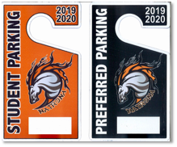

Vehicles parked in NCHS parking lots during the school day must have a current parking permit displayed. Student parking permits are issued on a first come-first served basis, with seniors having priority. The student parking lot is located on the west side of the building between Oak and Spruce Streets. **Students are not allowed to park in the staff/visitor lot east of the building**.

The MAC lot is reserved for students who are eligible for Preferred Parking. To receive a Preferred Parking permit, students must achieve the following:

Seniors: composite score of 25 or higher on the ACT.

All other students: “Advanced” ratings in all areas on the WY-TOPP.

Parking lots are NCHS property. Vehicles parked in the lots are subject to the same search policies as lockers and other school property. Vehicles parked on campus without a permit may be ticketed or towed. Additionally, students parking inappropriately or in reserved parking areas (including staff, handicapped, etc.) will be subject to disciplinary action and ticketing. Vehicles impeding the flow of traffic or interfering with school safety may be ticketed or towed. Students and parents must complete and sign the Student Parking Code of Conduct annually before a student can receive a parking permit.

**NCHS Student Parking Code of Conduct**

1. I will drive at a safe speed and operate my vehicle in a safe manner on and near campus.
2. My vehicle will have a parking pass displayed whenever the vehicle is on campus.
   1. The pass will either hang from the rearview mirror or be on the dashboard
   2. The permit number will be clearly visible from outside the vehicle
3. I will notify the Main Office if I permanently transfer my pass to a different vehicle, or if my vehicle receives a new license plate.
4. I understand that the MAC Lot is reserved for students who are eligible for Preferred Parking, and that all other students will park in the Student Lot only.
5. I will not park in the Staff Lot.
6. I will not leave trash in the parking lots.
7. I will not loiter (“hang out”) in the parking lots at any time (i.e., before school, after school, during lunch, etc.).
8. I understand that violating this code may result in:
   1. Loss of parking privileges
   2. School disciplinary action
   3. Ticket and fine from NCHS
   4. Citation from the Casper Police Department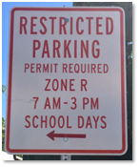
9. I understand that if I lose my parking privileges for any reason, my parking pass will be confiscated and I will not be allowed to park on campus.

**Restricted Parking Off-Campus Near NCHS**

The City of Casper has designated some neighborhoods near NCHS as restricted parking areas. Only neighborhood residents with Zone R permits are allowed to park in these areas. Students parked in a restricted parking area may be ticketed by the Casper Police Department and assessed a $50 fine. Please be aware of any restricted parking signs where you park.

**PIC Parking for NCHS Students**

NCHS students attending Pathways Innovation Center (PIC) are to park in the south (near the mountain) parking lot. A PIC parking permit will be required. Please obtain a PIC parking permit from the main Pathways office. The same parking lot rules apply to the PIC parking lot as the NCHS parking lot.

**Progress Reports**

Grade reports are issued to students every 4 1/2 weeks. They only reflect progress in class and are not permanent grades. These grade reports will allow students and parents to monitor academic progress. All grades and assignments are viewable through the Infinite Campus Parent and Student Portals. Semester grades are the only grades that are posted on a student’s permanent academic record.

**Public Displays of Affection**

Public displays of affection (PDA) distract from our learning environment and are prohibited. PDA may include, but is not limited to: acts of kissing, embracing, and/or sexual conduct. Repeated violations will result in disciplinary consequences.

**Student Class Rank**

Student class rank is calculated using a student’s NCSD weighted GPA. Please see the regulation in [Policy 6410](http://go.boarddocs.com/wy/ncsd1/Board.nsf/goto?open&id=95245E09DEAB) for a detailed description of the computation methods.

**Student Schedules**

**Course Load Expectations**

We expect all students to enroll in and maintain a full class schedule. Exceptions may be granted to seniors with administrative approval. The minimum seniors will be expected to be enrolled in is 5 blocks, plus Mustang Connections. BOCES courses and work experience will count toward this expectation. Due to safety concerns, if students have less than a full schedule, they will not be allowed to loiter on campus during open blocks. Accommodations may be made by administration, in conjunction with students, upon request.

Seniors who carry fewer than 5 courses (not including Mustang Connections) are ineligible for school activities. Students and parents/guardians are asked to sign a waiver acknowledging their understanding of this fact. This includes athletic and non-athletic competitions such as FFA, Band, Choir, Forensics, etc. This waiver is available in the counseling office.

**Alternative and Dual-Enrollment Courses**

College, on-line, and BOCES courses which are not offered on campus must be approved by administration when offered during the academic day, as these courses may impact a student’s ability to meet graduation requirements. Accommodations will be made in order to ensure attendance of off-campus courses when possible. Articulated courses will be handled by the college registrar, in conjunction with NCHS counselors and classroom teachers. Online courses must be approved by the counselor **PRIOR** to enrolling if high school credit is to be issued.

**Schedule Changes**

Class schedules are developed based on student requests made during spring registration. Students are required to attend the classes they select during registration. Changes in a schedule will only be considered for the following reasons:

1. The student does not have a full schedule.

2. The student has not taken/passed the prerequisite course for a course listed on their schedule.

3. The student did not request the course on their schedule.

4. Changes in placement (i.e. I.E.P., 504) have occurred.

Parent/guardian, sending and receiving teachers, and administrator approval is required for all schedule changes. Schedule changes for any reason except those identified above will only be made during two designated schedule change times: Tuesday, August 27, and Thursday, August 29, 4:00 – 7:30 PM.

**Withdraw Pass/Fail:** Administrator approval is required to drop any course after the first 4 1/2 weeks of each semester. Withdrawals will not be considered after the first and third quarter grading periods without a “WF” on a student’s transcript.

**Safe School Suspension Lab**

Students who are suspended from school for more than one day may be assigned to the SSSL (Safe Schools Suspension Lab) located behind Casper Classical Academy. Assignments from NCHS teachers will be provided there. If a student refuses to attend this program, no credit will be issued for the assignments missed, and the absences will not be excused.

**Sexual Harassment**

Sexual harassment is defined as, but not limited to, unwelcome sexual advances, requests for sexual favors, or other verbal or physical conduct of a sexual nature. Sexual harassment may include the following: verbal harassment, including derogatory comments or name-calling, physical harassment or interference with movement, or visual harassment such as derogatory cartoons, drawings or posters. Complaints of sexual harassment may be made to any member of the staff. All complaints of sexual harassment or harassment of any kind will be investigated. A complete description can be found in the [Natrona County School District Student/Parent Handbook.](https://docs.google.com/document/d/1gO77Hh_P5cF2T9-RIJRYJlp8Ct2lKN3h4mLi-x9ZBmo/edit)

**School Safety and Security**

NCHS has supervised points of entry at the following doors: east main entrance, west main entrance, and MAC entrance. Following the 8:20 bell, all doors at NCHS are locked and parents/visitors needing entry can be admitted through either the East main entrance or the West main entrance when the office staff “buzz them in”. For safety purposes, students are not to prop or open locked doors to allow anyone to enter the school. Students caught doing so will face disciplinary consequences.

Students and their backpacks may be searched if school staff or a School Resource Officer has reasonable suspicion that a student may be in violation of school/district policies or criminal code. No weapons of any type are allowed on campus, including AirSoft and paintball guns. **No knives of any type are allowed, regardless of blade length.**

Anyone with a safety and security concern should contact an administrator, staff member, or School Resource Officer, either in person or through [Safe-2-Tell Wyoming.](https://www.p3tips.com/tipform.aspx?ID=334)

**School Dances**

School dances at NCHS are open to NCHS students who are eligible for activities (see Activity Eligibility requirements on page 6), have had no major behavior referrals during the current school year, and are not on an attendance contract. Students wishing to bring a student from another high school, or a non-student guest (< 20 yrs. of age) must have permission from an administrator. Non-NCHS students must meet the same eligibility criteria as NCHS students. Students may only purchase dance tickets for themselves and their non-NCHS guests. **Tickets are non-transferrable.** There is no re-entry at dances.

Attendance at dances is contingent on respectful and appropriate attire, behavior, and dancing . Students who are denied entrance or removed from a dance for any reason will not receive a ticket refund.

**Student Drop-Off/Pick-Up Area**

The student drop-off/pick-up area is South Oak Street on the west side of the main building. On campus, South Oak Street is a two-lane, one-way road that proceeds north and then west. It exits campus on South Spruce Street. Students will be dropped off or picked up only from the right lane before Oak Street turns left/west. The entire left lane is for thru traffic, as are both lanes after the left/west turn. Please do not drop off or pick up students from the left lane or after the turn—doing so is a safety hazard and impedes the flow of traffic.

For student and staff safety, the east parking lot and the bus lane on the east side of the building are not to be used for student drop-off or pick-up. **Please drop-off and pick-up your students on the west side of the building.**

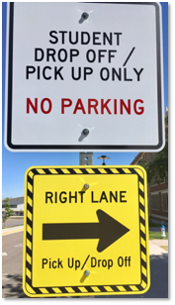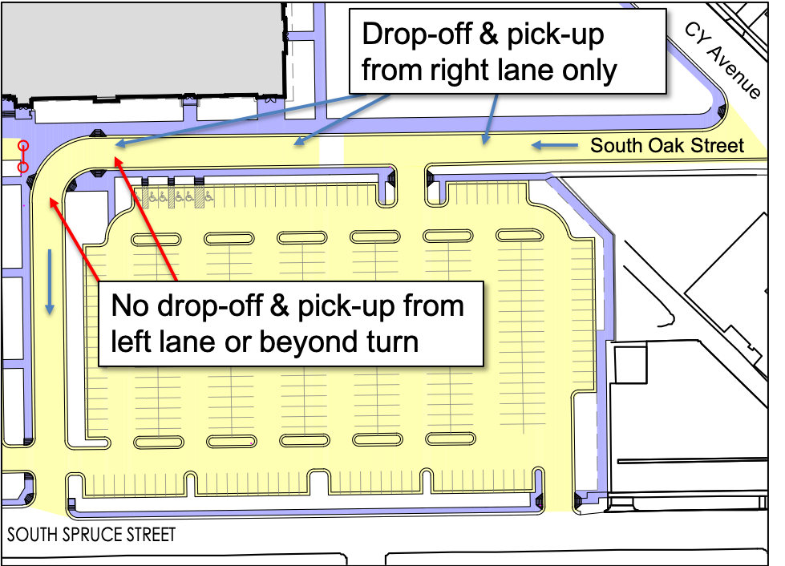

**Student Insurance**

The school district does not carry accidental injury insurance to cover students injured at school. Students who are not covered by family insurance are urged to purchase single student accident insurance. Some extracurricular activities require students to have accidental injury insurance. This insurance information is available to all students at registration/verification or in the main office.

**Technology**

All students at NCHS will be provided technology for academic and appropriate personal use. These devices are valuable tools to be used by students to enrich course objectives and to complete assignments. Their primary use is for academics. A secondary use may be for students’ personal email, social networking, and downloading music. However, the school reserves the right to take possession of an electronic device at any time without prior notice.

Students are expected to follow the school and district policies relating to the care and use of this equipment. Annually, students and their parents/guardians will sign the “NCHS-Instructional Technology Acceptable Use Agreement”, “Student Pledge”, and “Parent/Guardian & Student Agreement for the Loan of NCSD Electronic Device” . These forms will be sent home in the

Back-to-School packet each year and can be found in the appendix of the NCHS Student handbook.

Students should not use their electronic device inappropriately nor visit sites that are inappropriate. Students who are found to have inappropriate material on them may lose their privileges, or have their privileges restricted, for the remainder of the school year. If in doubt about what is deemed inappropriate, ask a teacher or administrator.

**Vaping**

Students who are in possession of vaping supplies, who share/distribute vaping supplies with other students , or are caught vaping will receive the following consequences:

1st Offense- 3-day suspension

2nd Offense- 6-day suspension

3rd Offense- 10-day suspension, with possible recommendation for expulsion.

Suspension may be replaced in whole or part, by completion of a vape education course provided by NCHS. Multiple offenses will result in required completion of the vape education course prior to re-entry following suspension.

**Visitors**

Individuals who are not currently enrolled NCHS students or staff are not allowed on the NCHS or PIC campuses unless they receive a visitor’s pass from the main offices (NCHS & PIC) or the attendance office (NCHS). Visitor Passes will not be approved for guests to visit staff members or students during the school day when school is in session. Violators will be prosecuted under sections of the City Ordinance dealing with trespassing. Students are not allowed to bring guests to class, although parents are always welcome.

**Visiting Other School Campuses**

Students may not be on any other school’s campus during the school day. This includes during the lunch hour. You may not attempt to visit one of your former teachers at another school during the school day. Violations of this policy will result in disciplinary actions.

**Appendix**

**NCHS Instructional Technology Acceptable Use Agreement**

The purpose of the Natrona County School District’s 1:1 Digital Learning initiative is to increase student learning of 21st Century Skills and the Wyoming Content and Performance Standards, through continuous use and integration of technology across learning environments including school, home, and community. To achieve this, the NCHS is providing iPads for all students in grades 9-12. Computers and other devices may be used as well.

**Terms**

Students will comply at all times with the NCSD’s electronic device expectations.  Failure to comply may terminate student’s rights of possession, effective immediately, and the school may repossess the iPad. Any lost, stolen, or damaged iPads must be reported to school authorities immediately.

NCSD has legal title to the property at all times. The student’s right of possession and use is limited to and conditioned upon full and complete compliance with this agreement.

Teachers and staff may also set additional requirements for use within classrooms, lunchrooms, etc. NCSD reserves the right to confiscate and search an iPad to ensure compliance with the iPad Use Agreement and/or compliance with Natrona County School District’s expectations in the Student/Parent Handbook.

**Loss, Theft or Damage**

Should an iPad be damaged, lost, or stolen the student or parent/guardian should immediately notify the school administration.  If an iPad is stolen, the student/guardian should file a police report as soon as possible. If the iPad is lost, stolen, or damaged as a result of irresponsible behavior, the parent may be responsible for the full replacement cost.

In the event of a lost or stolen iPad a police report will be filed and NCSD may deploy location software to aid in recovering the iPad. Students who are no longer enrolled in NCSD must return the iPad, along with any other accessories, at the time they leave. If the student does not return the iPad, the device will be considered stolen.

**Monitoring and Supervision**

* Do not leave the iPad unattended in an unlocked classroom or during an extracurricular activity.
* Any attempt to “jailbreak” or remove the MDM profile may result in loss of privilege and/or suspension.
* Internet filtering is provided as a safeguard. Attempting to by-pass the Internet filter or MDM is prohibited.
* Students are responsible for the safety and security of the iPad and any activity on the device.
* The district may disable the iPad remotely to protect the device and/or data on the device.

**Transport**

* Do not leave the iPad in a vehicle for extended periods of time or overnight.
* Do not leave the iPad in visible sight when left in a vehicle.

**Content**

Applications (Apps) will be downloaded (synced) at school. School owned devices may be synced to a student’s personal computer, however, in the event the device runs out of memory, all such personal content will be subject to deletion to make room for required instructional content. Likewise, students may also load apps that are not part of the required instructional program, however, in the event the device runs out of memory, all such apps and content will be subject to deletion. NCSD will not be liable for lost or erased personal data or content. Apps or content purchased, downloaded, or created by the student are not the responsibility of the district. NCSD reserves the right to restrict apps or other content from being installed onto the device.

**Mobile Technology Precautions**

* Keep your iPad in the district-issued or approved case at all times.
* Keep iPads free of any writing, drawing, stickers, or labels that are not applied by NCSD.
* Do not set books on the iPad.
* Do not have food or drinks around the iPad.
* Wipe surfaces with a clean, dry soft cloth.
* Avoid touching the screen with pens or pencils.
* Do not leave the iPad exposed to direct sunlight or near any heat or moisture sources for extended periods of time.
* Students should not photograph any other person without that persons’ consent. Respect the privacy of others.
* The iPad is subject to routine monitoring by NCSD. Upon request of any NCSD staff member, a student must immediately surrender their device.

**Cyber Bullying**

The highest level of **Digital Citizenship** is expected from each student. Electronic devices and network access will be available to students who adhere to the strict level of Digital Citizenship. NCSD policy, 5730 & 5440, strictly prohibits cyber bullying. Cyber-bullying is bullying through the use of technology or any electronic means. State law prohibits bullying.

Harassment, intimidation or bullying means any intentional gesture or any intentional written, verbal or physical act that a reasonable person under the circumstances should know will have the effect of:

1. Harming a student physically or emotionally, damaging a student’s property or placing a student in reasonable fear of personal harm or property damage; or
2. Insulting or demeaning a student or group of students, causing substantial disruption in, or substantial interference with, the orderly operation of school; or
3. Is so sufficiently severe, persistent or pervasive that it creates an intimidating, threatening or abusive educational environment for a student or group of students.

“Written” acts include, but are not limited to handwriting or typed communications, e-mails, text messages, blogs and other forms of electronic communications.

A “school” as defined in this policy includes a classroom or other location on school premises, a school bus or other school related vehicle, a school bus stop, an activity or event sponsored by a school, whether or not it is held on school premises, and any other program or function where the school is responsible for the children. ( WY Stat § 21-4-313)

**Students using school issued electronic devices or the district network to participate in Cyber Bullying may lose possession and access to both the device and the network. Students who engage in cyber bullying, harassment or intimidation shall be subject to disciplinary action, up to and including suspension or expulsion**.

**Student Responsibilities**

* Find my iPad must be turned on at all times.
* NCSD is not responsible for the loss of any personal files that may be deleted from an iPad.
* In the event of any disciplinary action, completion of all class work remains the responsibility of pupil.
* Students are responsible for home Internet connections. The school will **not** provide support for home Internet or networks.

**Maintaining and Safeguarding**

* iPad batteries are required to be charged and be ready to use in school.
* Memory space is limited. Academic content takes precedence over personal files and apps.
* iPads belonging to other students are not to be tampered with in any manner.
* If an iPad is found unattended, it should be given to the nearest staff member.

**Prohibited Use of the iPad**

* Accessing or Posting Inappropriate Materials – All material on the iPad must adhere to the NCSD Internet Use Agreement Policy & the Student Technology Agreement. Students are not allowed to send, access, upload, download or distribute offensive, threatening, pornographic, obscene, or sexually explicit materials.
* Cameras – students must use good judgment when using the camera. The student agrees that the camera will not be used to take inappropriate, illicit, or sexually explicit photographs or videos; nor will it be used to embarrass anyone in any way. ***Any use of camera in restrooms or locker rooms, regardless of intent, will be reported to the School Resource Officer.***
* It is illegal for students to transmit or possess pornographic images of themselves or other students.
* Any student caught trying to gain access to another student’s accounts, files, or data will be subject to disciplinary action.
* Malicious Use/Vandalism – any attempt to destroy hardware, software, or data will be subject to disciplinary action.
* Inappropriate media may not be used as a screensaver or background photo. Presence of pornographic materials, inappropriate language, alcohol, drug, or gang related symbols or pictures will result in disciplinary actions.

Student Name: ___________________________________________________(Please Print)

Student Signature: ___________________________________________ Date: ________________

Parent Signature: ____________________________________________ Date: ________________

**Student Pledge**

(Please put your initials on the line after each statement once you have read it. Your initials on the line indicate your agreement).

1. I will take care of my iPad. I will be issued the same mobile device each year. __

2. I will never leave my iPad unattended or in an unsecure location. _____

3. I will never loan out my iPad to other individuals. _____

4. I will know where my iPad is at all times. _____

5. I will charge my iPad daily. _____

6. I will keep food and beverages away from my iPad since they may cause damage to the iPad. ____

7. I will not disassemble any part of my iPad or attempt any repairs. _____

8. **I will protect my iPad by using the district-approved case at all times**. _____

9. I will use my iPad in ways that are appropriate and educational. _____

10. I will not place decorations (such as stickers, markers, etc.) on the iPad. _____

11. I can decorate the iPad **case**, above the identification label, with appropriate stickers, markers, etc. ___

12. I understand my iPad is subject to inspection at any time, without notice, and remains the property of NCSD. _____

13. I will not “Jailbreak” or attempt to alter the operating system in any way. _____

14. I will follow the policies regarding internet and technology use at all times. _____

15. I will file a police report if my iPad is stolen. _____

16. I will be responsible for all intentional damage. _____

17. I agree to pay for the replacement of my power cords, charger, and case in the event any of these items are damaged, lost, or stolen. _____

18. I will “Backup” my iPad’s content by turning on the Backup option in my iPad Settings.

Student Name:_____________________________________________________________(Please Print)

Student Signature: ___________________________________________ Date: _________________

Parent Signature: ____________________________________________ Date: __________________

**Parent/Guardian and Student Agreement**

**For Loan of Natrona County School District (NCSD) Electronic Device**

**Parent(s)/Guardian Agreement**

I am the parent/guardian of a Natrona County School District student who is being loaned an electronic device by NCSD for the current school year. Should my student have 10 or more consecutive absences, or within 10 days of the last day of school, whichever is earlier (the “Return Date”), I agree to immediately return the device and its accessories to school authorities in their original condition (good and fully operable). Upon the return of the device, I agree to keep the return receipt I will receive. *If damages or loss of the device and accessories occur, I acknowledge and agree that I may be sued in civil court. I understand that if I do not return the device and its accessories as agreed in this document, or if I cannot produce the return receipt, criminal charges and/or civil legal actions may result.* NCSD has the right to demand immediate return of the device and its accessories to NCSD at any time. Failure to return the device to NCSD upon demand may result in civil and/or criminal penalties under the laws of the State of Wyoming.

**Student Agreement**

I am a Natrona County School District student who is being loaned an electronic device by NCSD for the current school year. I agree to return the electronic device and its accessories in their original condition (good and fully operable), to school authorities should I have 10 or more consistent absences or within 10 days of the last day of school, whichever is earlier (the “Return Date). Upon the return of the electronic device, I agree to keep the return receipt I will receive. *If damages or loss of the electronic device and accessories occur, I acknowledge and agree that I may be sued in civil court. I understand that if I do not return the electronic device and its accessories as agreed in this document, or if I cannot produce the return receipt, criminal charges and/or civil legal actions may result.* NCSD has the right to demand immediate return of the electronic device and its accessories to NCSD at any time. Failure to return the electronic device to NCSD upon demand may result in civil and/or criminal penalties under the laws of the State of Wyoming.

**Parent(s)/Guardian and Student**

We understand and agree that in exchange for the loan of the electronic device for educational purposes, it is our responsibility to take the best possible care of the electronic device loaned to this student by the Natrona County School District (NCSD) and to return the device and all accessories on time and in good, fully operable condition. *By signing this agreement, we accept the obligation to pay for the full repair/replacement cost within 10 days of notice each time that this student’s NCSD electronic device is lost, stolen, damaged or destroyed. If an electronic device is lost or stolen, we agree to make a police report within 24 hours to activate the investigation.* This report may be made at the Safe Schools or Security Office during school hours, or at the Casper Police Department over holidays or extended breaks*.*  We understand and agree that refusal to sign this agreement may result in the student not being able to take the electronic device home, although the student may have restricted use within the school. By signing this agreement, we acknowledge that both parent/guardian and student have completed the online training at natronaschools.org. **ADDITIONAL NOTICE ABOUT FINANCIAL RESPONSIBILITY AND OTHER LEGAL ISSUES INCLUDING CRIMINAL PENALTIES.** For purposes of these notices, **'you' and 'your', refer to the person(s) who sign this Agreement.** Your signature on the *Parent/Guardian and Student Agreement For Loan of Natrona County School District (NCSD) Electronic device* constitutes your acknowledgement that you have read and understood each of the following notices:  **You are responsible for loss of or damage to the electronic device even if someone else is at fault or the cause is unknown.** You are responsible for the cost of repair or full cost of replacement up to the value of the electronic device. Your Return Date is the date agreed upon in the Parent(s)/Guardian Agreement and the Student Agreement, above. If you wish to extend the period beyond the return date shown, you must go to an NCSD facility and obtain a new Agreement. Extensions are not automatic and may be refused by NCSD at its sole discretion. In addition, any extension is subject to availability. **YOU ARE HEREBY NOTIFIED THAT failure to return the electronic device and all accessories to NCSD by the Return Date or upon demand by NCSD, whichever is earlier, may cause NCSD to file a report with law enforcement officials. You may be subject to arrest, prosecution, and to civil and criminal penalties under the laws of the state of Wyoming. YOU ARE FURTHER NOTIFIED THAT NCSD shall have the right to make periodic checks on the location and condition of the electronic device and its accessories. If NCSD determines in its sole discretion that the electronic device is missing or is not in the student’s possession, or is not returned to NCSD on demand, NCSD shall have the right, without further notice to you, to file a report with law enforcement officials. You may be subject to arrest, prosecution, and/or to civil and criminal penalties under the laws of the State of Wyoming.**

___________________________________ __________________________________ ______ ___________

Student’s Printed Name Student’s Signature Grade Date

___________________________________ ________________________________ _________

Parent/Guardian’s Printed Name Parent/Guardian’s Signature Date



NATRONA

COUNTY SCHOOLS



Handbook Acknowledgement Form

I have received and reviewed the [Natrona County School District Student/Parent Handbook](https://docs.google.com/document/d/1gO77Hh_P5cF2T9-RIJRYJlp8Ct2lKN3h4mLi-x9ZBmo/edit). The handbook can also be accessed with the following QR code:



I have also received and reviewed Natrona County High School’s handbook located on the home page @ NatronaCountyHS.org.

I agree to follow the handbook rules. I understand that my failure to follow the handbook rules may result in disciplinary action.

Printed Name Grade

**______________________________________________________________________________**

Student Signature Date

I have received and reviewed the Natrona County School District Student/Parent Handbook and the Natrona County High School handbook referenced above. I understand that the handbook rules apply to my student and that s/he must follow them. I understand that my student’s failure to follow the handbook rules may result in disciplinary actions.

Printed Name

**______________________________________________________________________________**

Parent Signature Date



